**Experiment -1**

**Installation of Oracle**

**Objective:** Implement Oracle database system to streamline data storage, enhance performance, and ensure reliable management for organizational needs and growth.

**Prerequisites:**

1. Adequate hardware resources (CPU, RAM, storage).
2. Supported operating system installed (e.g., Windows, Linux, Unix).
3. Oracle database software installer downloaded.
4. Appropriate user permissions and privileges.
5. Network configuration for connectivity (if applicable).
6. System backups and recovery plan in place.

**Steps of installation:**

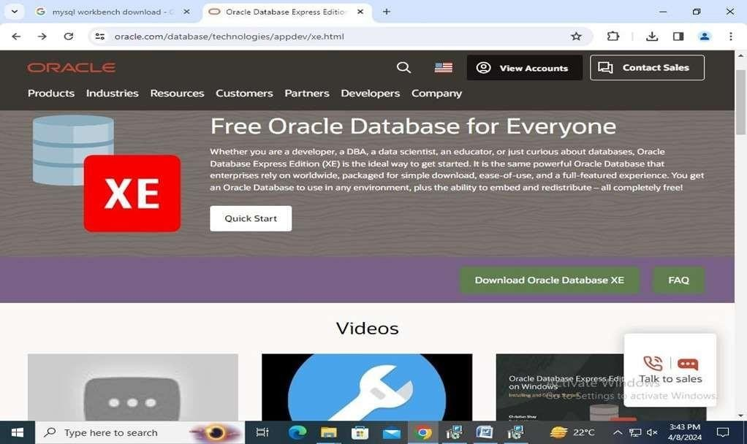**Step 1: Prepare Your System:** Ensure your computer meets Oracle's hardware and software requirements. Download the Oracle database software installer from the official website.

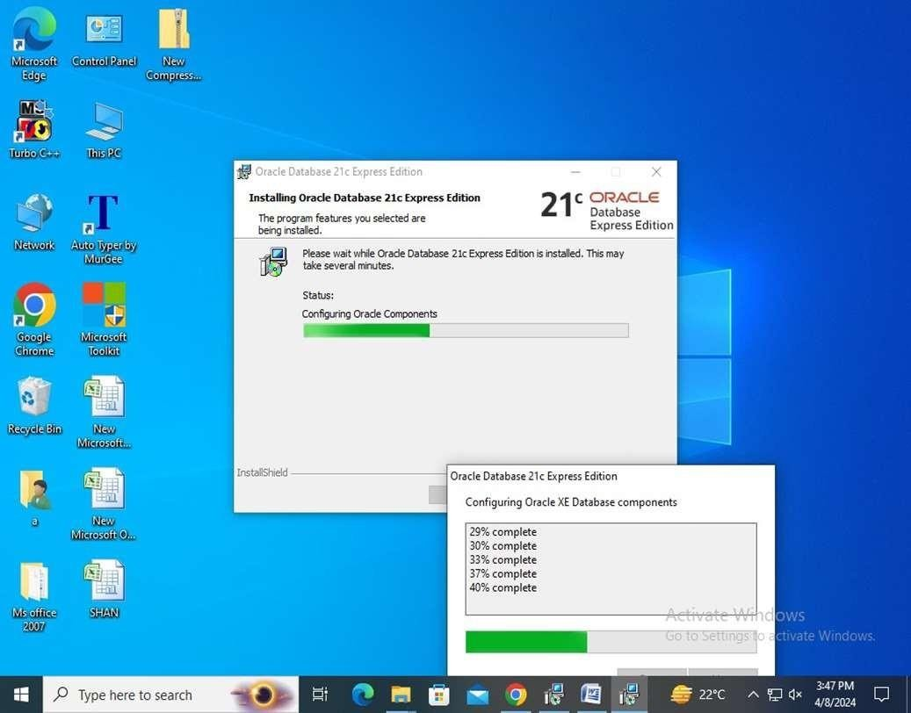**Step 2: Install Required Software:** Install the necessary software components like the operating system and any required patches or updates as per Oracle's recommendations.

**Step 3: Configure System Settings:** Adjust system settings such as memory allocation, kernel parameters, and network configurations to meet Oracle's specifications.

**Step 4: Create Oracle User Account:** Create a dedicated user account with appropriate permissions for Oracle database installation and operation.

**Step 5: Run Oracle Installer:** Launch the Oracle database installer and follow the on-screen instructions. Choose installation options like database edition, installation type, and installation location.

**Step 6: Configure Database:** During installation, configure the database settings including database name, listener configuration, and administrative passwords.

**Step 7: Complete Installation:** Wait for the installation process to complete. Once finished, verify the successful installation and configuration of the Oracle database.

**Step 8:Start Sql Plus :** Start sql plus and run databases quries.

**Conclusion:**

Setting up Oracle database on your computer involves preparing the system, installing required software, configuring system settings, creating a dedicated user account, running the Oracle installer, configuring the database, and completing the installation. Following these steps ensures a smooth setup process for efficient data management and retrieval.

**Experiment-2**

**Objective:** Develop an ER model for hospital to organize data, improve efficiency, and enhance management of patient information and resources.

**Tools Used:**

1. Pen & Paper
2. Database
3. Computer
4. Designing Software

**Theory:**

**1. Entity:** An entity may be any object, class, person or place. In the ER diagram, an entity can be represented as rectangles.Consider an organization as an example- manager, product, employee, department etc. can be taken as an entity.

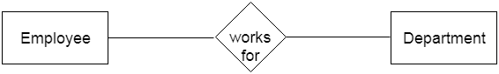

**a. Weak Entity**: An entity that depends on another entity called a weak entity. The weak entity doesn't contain any key attribute of its own. The weak entity is represented by a double rectangle

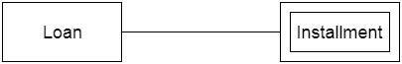

### 2. Attribute: The attribute is used to describe the property of an entity. Eclipse is used to represent an attribute.

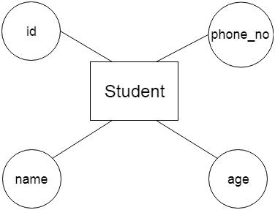

**a. Key Attribute**: The key attribute is used to represent the main characteristics of an entity. It represents a primary key. The key attribute is represented by an ellipse with the text underlined.

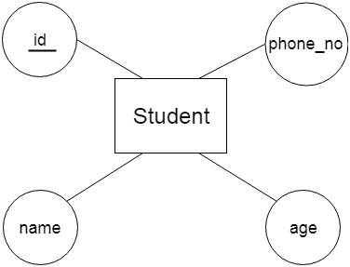

**b. Composite Attribute**: An attribute that composed of many other attributes is known as a composite attribute. The composite attribute is represented by an ellipse, and those ellipses are connected with an ellipse.

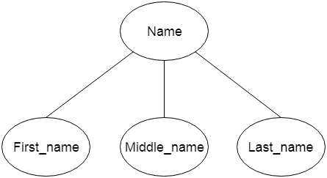

**c. Multivalued Attribute**: An attribute can have more than one value. These attributes are known as a multivalued attribute. The double oval is used to represent multivalued attribute.

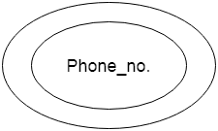

**d. Derived Attribute**: An attribute that can be derived from other attribute is known as a derived attribute. It can be represented by a dashed ellipse

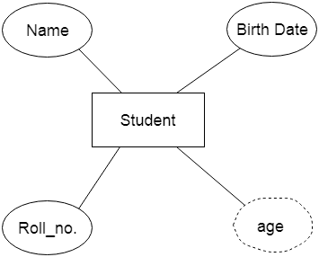

### 3. Relationship: A relationship is used to describe the relation between entities. Diamond or rhombus is used to represent the relationship.

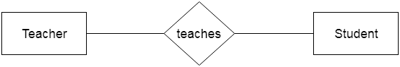

**E.r. Diagram of Hospital: -**

